WeatherPy Observations

By Alexis Fox

Weather throughout the world is a compelling subject. After completing the WeatherPy homework, I observed the following:

Although the query returned 618 cities, there was only data on file for 543 cities.

You would think that the temperature would be highest at the equator but it appears that there are higher temperatures 20 to 40 degrees to the East of the equator.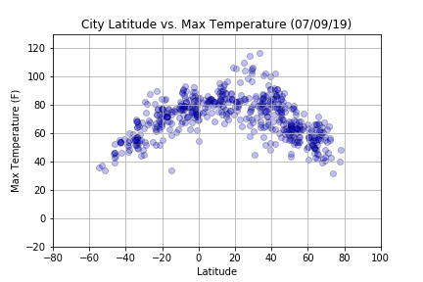

Just like one would expect, as the temperature gets higher, so does the humidity.